1- [20 pts] Provide a short answer to the following questions.

1. 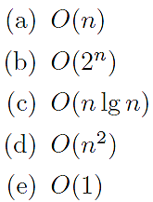Arrange the following classes of functions (in Big-O notation) in increasing order:

(b) What is the benefit to using a binary tree over other data structures?

(c) What is the balance property all Red-Black Trees seek to maintain?

(d) What is the balance factor in AVL Trees?

2- [10 pts] Give an algorithm (pseudocode) to count the number of leaf nodes in a binary tree. What is its computational complexity?

3- [25 pts]

1. [10 pts] Draw a binary search tree for the Pre-order traversal of sequence 10, 4, 2, 1, 6, 5, 7, 17, 13, 16, 20, 29, 25, 31, 30
2. [15 pts] Provide all of the listed traversals for the above binary search tree.
   1. In-order traversal.
   2. Post-order traversal.
   3. Breadth-first traversal.

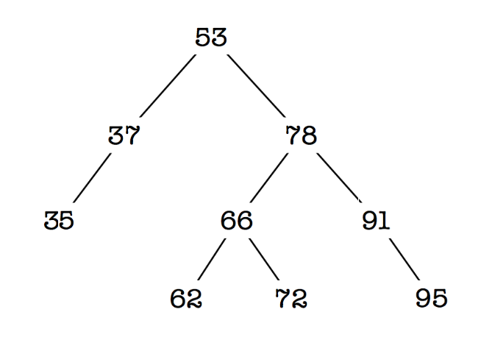4- [20 pts] You are given the following binary search tree.

1. Color the nodes of the tree red and black so that it becomes a valid red-black tree. If you don't have a colored pen, you could e.g. draw a circle for red nodes and a square for black nodes.
2. Insert 60 into the tree using the red-black insertion algorithm. Write down all the necessary steps to keep the tree balanced.
3. 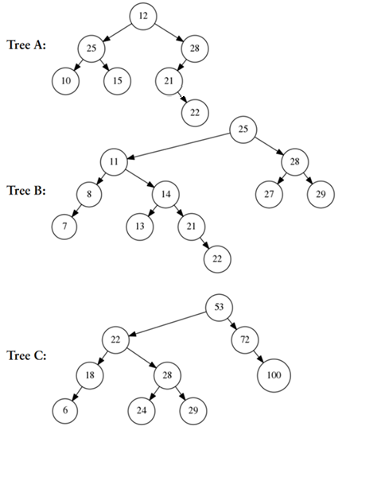[25 pts] Have a look at the following BS trees
4. One of these trees is an AVL tree. Which one?
5. Insert 30 into the tree using the AVL insertion algorithm. Write down all the steps to keep the tree balanced.
6. Delete node 22 from the tree of part b (after inserting node 30). Write down all the steps to keep the tree balanced.